Pleasant Grove Youth Football (PGYF)

Information for those new to youth tackle football

Players will need the following for each practice:

Helmet. PGYF will provide your player with a 5-star safety rated Xenith X2E helmet. DO NOT CUT THE STRAPS on this helmet. The straps are part of the integrated helmet bonnet and cutting the straps may make the helmet unusable for a player next year. Remind your players to NEVER sit on their helmet. When it is off their head, they need to be holding it or set to the side. Sitting on helmets may weaken the helmet structure. Wipe down the inside of the helmet regularly with a disinfecting wipe.

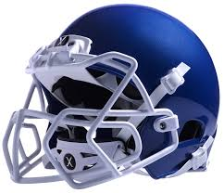

Practice pants or a football girdle and volleyball knee pads with shorts worn over the top. They come in a variety of brands and colors. Don’t use game pants to practice in.

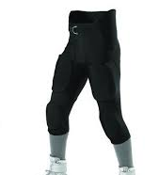
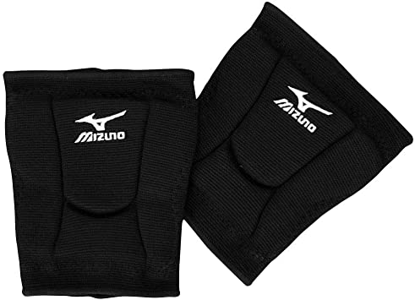
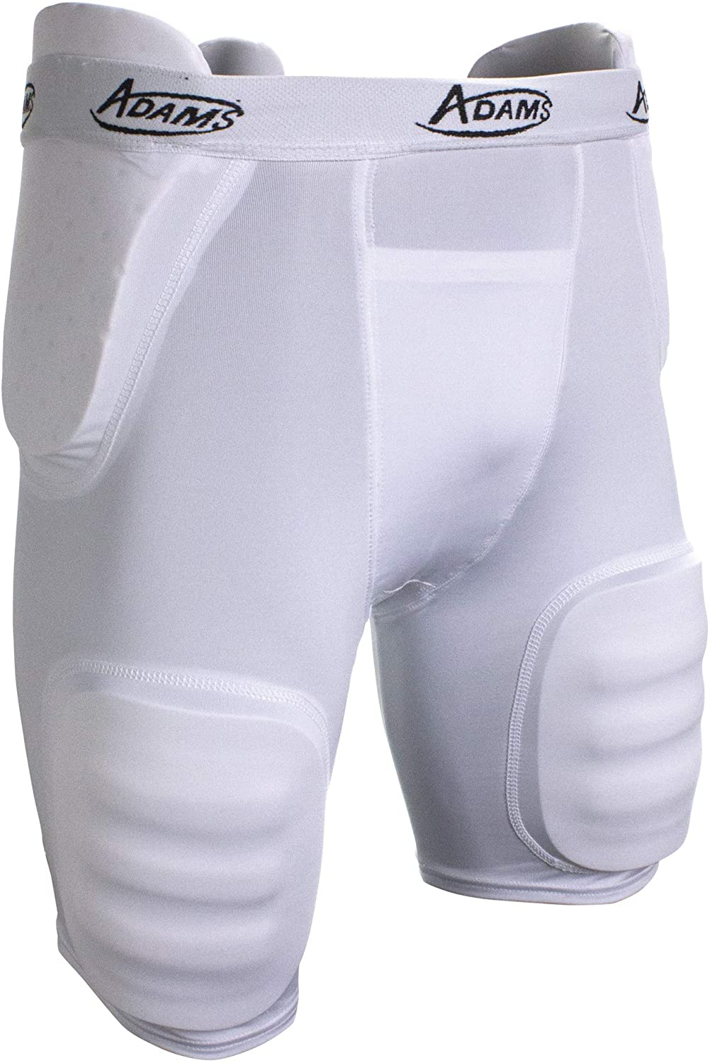

Shoulder Pads. PGYF will provide your player with shoulder pads. Please don’t cut any straps. Wipe down regularly with a disinfecting wipe.

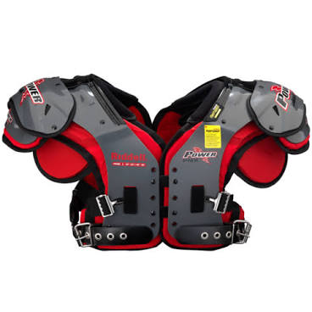

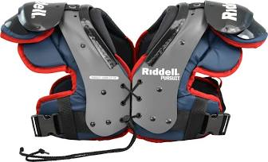

Practice Jersey or old t-shirt that will fit over the shoulder pads.

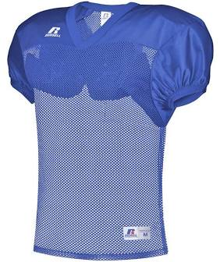

Cleats – make sure they are football cleats (no metal spikes). There are a variety of brands and styles in a variety of price ranges.
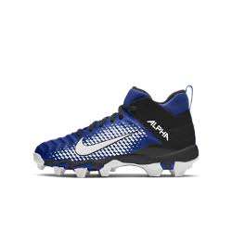

Water Jug – Provide your player with enough water to last throughout practice (32 oz, 64 oz, ½ gallon or bigger – whatever works best for you and your player). Please write your players name on their water jug.

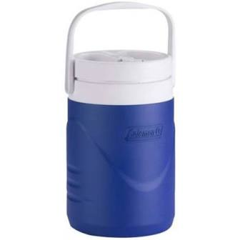

Mouthguard: Your player must wear a mouthguard at all practices and games. PGYF will provide a mouthguard for your player. Many parents choose to buy their own. There are a lot of brands and styles available. Coaches are provided with extra mouth guards should a player lose theirs. If your player has braces, you will need a braces mouthguard (photo on right) or talk to your orthodontist about custom braces mouthguards.



